PCA Part 1 - Geometric Intuition Notes
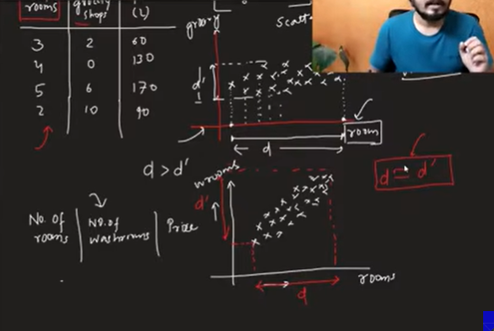

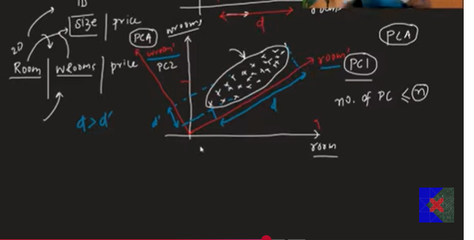

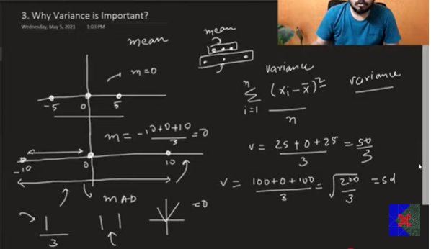

What is PCA?
Principal Component Analysis (PCA) is an unsupervised machine learning algorithm used for dimensionality reduction.
It reduces the number of features (dimensions) in a dataset while preserving as much important information (variance) as possible.
PCA = Transform High-Dimensional Data → Low-Dimensional Data

Key Facts About PCA
- Type: Unsupervised Learning
- Technique: Feature Extraction
- Purpose: Dimensionality Reduction
- Works with: Numerical Data
- Invented: Around the 1900s (widely used for decades)
- Scikit-learn Class: PCA

Why Do We Need PCA?
Datasets with many features can cause problems such as:
- Slow model training
- High memory usage
- Overfitting
- Difficult visualization
- Curse of Dimensionality
PCA solves these problems by reducing the number of features while retaining most of the information.

Two Types of Dimensionality Reduction

1. Feature Selection
Feature Selection removes unnecessary columns and keeps only the most important existing features.
Example:
Original Features
Age
Salary
Experience
City
Gender
After Feature Selection
Age
Experience
Salary
Existing columns are selected.

2. Feature Extraction (PCA)
Feature Extraction creates new features by combining existing ones.
Example
Original Features
Rooms
Bathrooms
↓
New Feature
Flat Size
The original columns are transformed into a new feature.
PCA is a Feature Extraction technique.

Main Goal of PCA
PCA transforms a dataset into fewer dimensions while preserving the maximum amount of information (variance).

Real-Life Analogy (Photographer)
Imagine a football match happening in a 3D stadium.
A photographer wants to print the match in a newspaper, which is 2D.
The photographer changes the camera angle until the picture captures the maximum amount of information.
Similarly,
PCA converts high-dimensional data into low-dimensional data while preserving the important structure of the data.

Benefits of PCA

1. Faster Machine Learning
Since the number of features decreases,
- Training becomes faster.
- Prediction becomes faster.
- Memory usage decreases.

2. Better Visualization
Humans can visualize only:
- 2D
- 3D
If a dataset has 100 features, we cannot visualize it.
PCA reduces it to 2 or 3 principal components, making visualization possible.
Example:
784 Features (MNIST Images)

↓

2 Principal Components

↓

Scatter Plot

Understanding Feature Selection
Suppose we have this dataset.
Rooms | Grocery Shops | House Price
Question:
Which feature is more important?
Most people would select
Rooms
because house price depends more on rooms than nearby grocery shops.
Feature Selection simply removes the less useful column.

Problem with Feature Selection
Consider another dataset.
Rooms | Bathrooms | House Price
Now,
Which feature should be removed?
Both are equally important.
Feature Selection struggles because neither feature should be discarded.

How PCA Solves This Problem
Instead of removing one feature,
PCA creates a completely new feature.
Example
Rooms
Bathrooms

↓

Flat Size
Flat Size contains information about both rooms and bathrooms.
No useful information is lost.
This is why PCA is called Feature Extraction.

Geometric Intuition Behind PCA
Imagine plotting data on two axes.
Y

|
|
|
|
|
|________________ X
If data spreads more along the X-axis,
X contains more information.
If data spreads equally along both axes,
Feature Selection cannot decide which feature is better.
PCA rotates the coordinate system.
Instead of using
- X-axis
- Y-axis
it creates
- Principal Component 1 (PC1)
- Principal Component 2 (PC2)
These new axes capture the maximum variance.

Principal Components
After rotation,
Old Features
X
Y
become
PC1
PC2
These are called Principal Components.
Important:
The number of principal components is always equal to the number of original features.
Example
Original Features | Principal Components
2 | PC1, PC2
5 | PC1–PC5
20 | PC1–PC20

Which Principal Component is Selected?
PCA selects the component having maximum variance.
Usually,
Variance(PC1) > Variance(PC2)
Therefore,
PC1 is more informative.

Why Does PCA Maximize Variance?
Variance measures how much the data is spread out.
More spread means more information is preserved.
If variance becomes very small,
different data points appear very close to each other after projection, making it difficult for machine learning algorithms to distinguish them.
Therefore,
PCA always tries to maximize variance.

Variance and Spread
Higher Variance
● ●

●

●
More information

Lower Variance
●●●●●
Most information is lost.

Why Not Use Mean Instead of Variance?
Mean only tells us the center of the data.
Variance tells us how spread out the data is.
PCA needs spread, not the center.

Variance Formula
[
\text{Variance} = \frac{\sum (x_i-\mu)^2}{N}
]
where
- (x_i) = data point
- (\mu) = mean
- (N) = number of observations
Higher variance means the data is more spread out.

Why Does PCA Use Variance Instead of Mean Absolute Deviation?
Mean Absolute Deviation uses the absolute value function.
The absolute value function is not differentiable at zero.
PCA relies on optimization techniques that require differentiable functions.
Therefore, variance is preferred.

Workflow of PCA
Original Dataset

↓

Standardize Data

↓

Compute Covariance Matrix

↓

Find Principal Components

↓

Select Top Components

↓

Transform Data

↓

Train Machine Learning Model

Advantages of PCA
- Reduces dimensionality.
- Faster model training.
- Reduces overfitting.
- Removes feature redundancy.
- Makes visualization easier.
- Preserves maximum variance.
- Creates new informative features.

Disadvantages of PCA
- Principal components are difficult to interpret.
- Works only with numerical features.
- Sensitive to feature scaling.
- Some information is always lost.
- Components have no direct real-world meaning.

Important Interview Questions

What is PCA?
A dimensionality reduction technique that transforms original features into new principal components while preserving maximum variance.

Is PCA supervised or unsupervised?
Unsupervised Learning

Is PCA Feature Selection?
No.
It is a Feature Extraction technique.

Why is variance maximized?
Because higher variance preserves more information and keeps data points distinguishable after dimensionality reduction.

Why is standardization required before PCA?
Because PCA is based on variance, and features with larger scales would otherwise dominate the principal components.

Exam Tips
- PCA = Principal Component Analysis.
- PCA is an unsupervised feature extraction technique.
- Used for dimensionality reduction.
- PCA creates new features, called Principal Components (PC1, PC2, ...).
- PC1 always captures the maximum variance.
- Higher variance means more information is preserved.
- PCA improves training speed, visualization, and reduces overfitting.
- Always standardize the data before applying PCA.

